Fall 2022   
Derek Stearns   
CSCI/MATH 4150/8156   
______________________________________________________________  
Homework Five

1. (2 pts) Show that for any simple planar bipartite graph G, m is less than or equal to 2n-4.

Since our graph is simple and bipartite, we know there are no odd cycles. And since any simple graph with > 2 faces must have at least a cycle with 3 sides, we know f = 2m/4 or f = 1/2m where n >= 3. If we use this in Euler’s formula n -m + f =2, we get n-m+(1/2m) >= 2. Simplifying to m <=2n-4.

2. (4 pts) Find the thickness and the crossing number of K2,2,2 and K4,4.

Thickness of K2,2,2 = 1 and crossing number = 0 since it is planar.

K4,4 Thickness is 2 and crossing number = 4

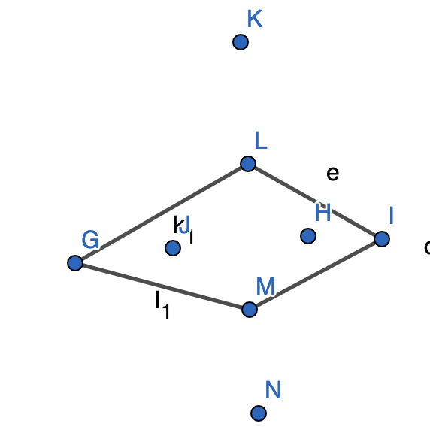 +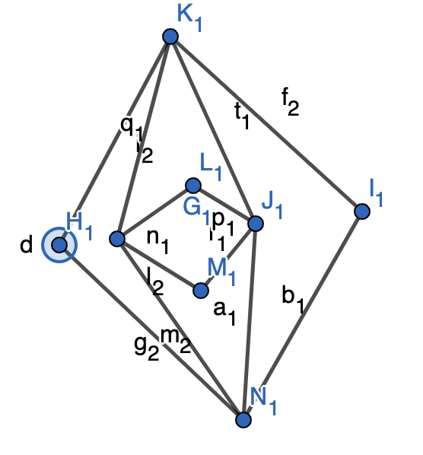=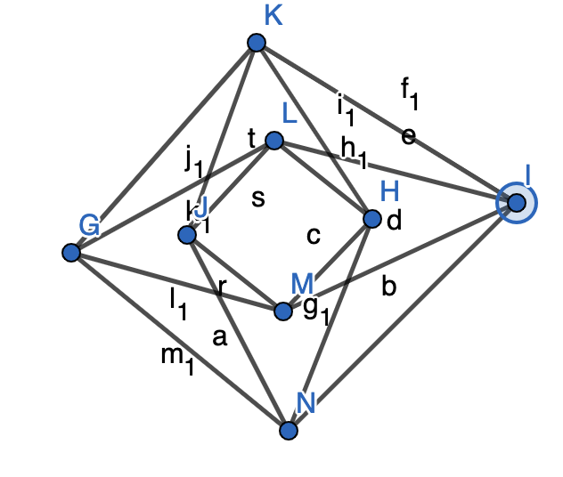

3. (2 pts) Show that the Peterson Graph is non-planar.

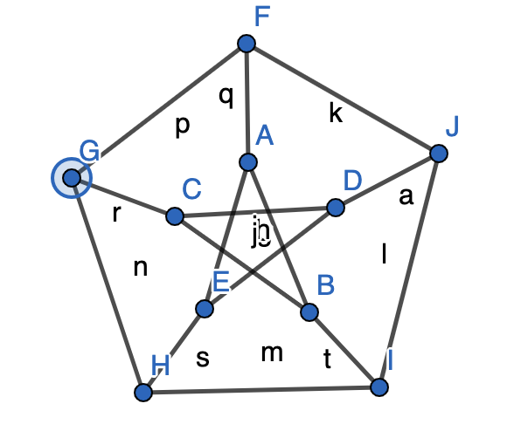

We know Kuratowski’s Theorem states a graph is planar iff it does not contain a subgraph of K3,3 or K5 contractions. The Peterson graph has such contractions between AF, DJ, BI, HE, and CG

4. (3 pts) Show that for n<=7, there always exists a graph G with n nodes such that both G and its complement are planar. Show that this is not possible for any graph with 11 nodes.

If we understand the maximum edges any (complete) graph could have with the number of nodes (7) m upper bound = 21 as understood by n(n-1)/2. The complement of this graph would be trivial. Since the minimum m of a complement would need to be 6 edges (spoke graph), this limits the upper bound to 15 edges of any graph G or its compliment. Since we know E <=3v-6 for any planar graph, the largest number of v possible is 7 where it creates 15 edges.

If a graph has 11 nodes, the minimum number of edges for a connected planar graph would be 10 edges. The maximum edges a completely connected 11 node graph would have is 55 edges. The complement of the minimum edged graph would be 45 edges. Getting closer to a middle number would create a graph of 27 and 28 edges on 11 nodes. Since e <= 3v-6 we cannot satisfy the equation for both the graph and its compliment.  
   
5. (4 pts) Verify Euler’s formula for the following planar graphs: (Hint: Represent all parameters in terms of k).   
a) Cycle graph Ck with k nodes

Euler’s formula is n -m + f =2 where n = k in a cycle graph and m will always = n (k). Therefore, k – (k) + f = 2; where the number of faces of a cycle will always be 2. Thus all Cycle graphs are planar.

b) Board graphs Bk formed by k*k chessboard with k2 squares

A board graph of any k*k can be represented as a bipartite graph. Where k is the number of edges on a side of a board. K*K = f. And (k+1)^2 = n. And m = 2k*sqrt(n). We replace m’s sqrt(n) in terms of k to get:

(k+1)^2 – 2*k(k+1) + f = 2 which simplifies to f = k^2 +1 which will always be true for a board graph.

c) Spokes graphs Sk formed by a central node and k Spokes.

Since spoke graphs will always have m = n – 1, and f will always = 1 since no cycles can exist in a spoke graph, k – (k-1) + 1 = 2, which is true.

d) Complete bipartite graph K2,k

Conceptually we know we can flip all edges belonging to one of the two nodes in K2 over the set of Kk so that any bipartite K2,k is planar. Let k = n – 2 and m = 2k where k + 2 – 2k + f = 2 which simplifies to f = k which is true as a bipartite graph will not contain odd cycles and for each additional k, adds a new even cycle (face) due to its completeness.

6. (3 pts) Apply the planarity testing algorithm on the complete bipartite graph K2,3.

The condition is not satisfied that:

f G contains one or more degree-two vertices, then G is planar if the graph, that  
results from replacing any degree-two vertex along with the two incident edges  
by one edge, is planar.

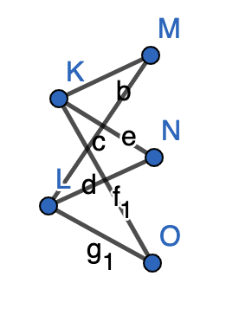 =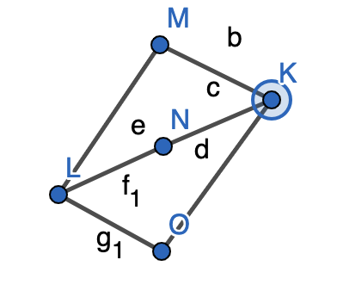after replacing 2-degree nodes:

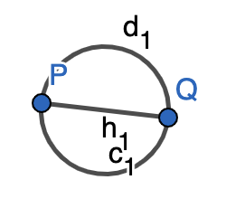which is planar

7. (6 pts) For each of the following undirected graphs, check whether it is a comparability graph or not. For the comparability graphs ones, find the corresponding transitive orientation, Hasse Diagram, and then use the diagram to find a maximum clique in the graph.   
   
 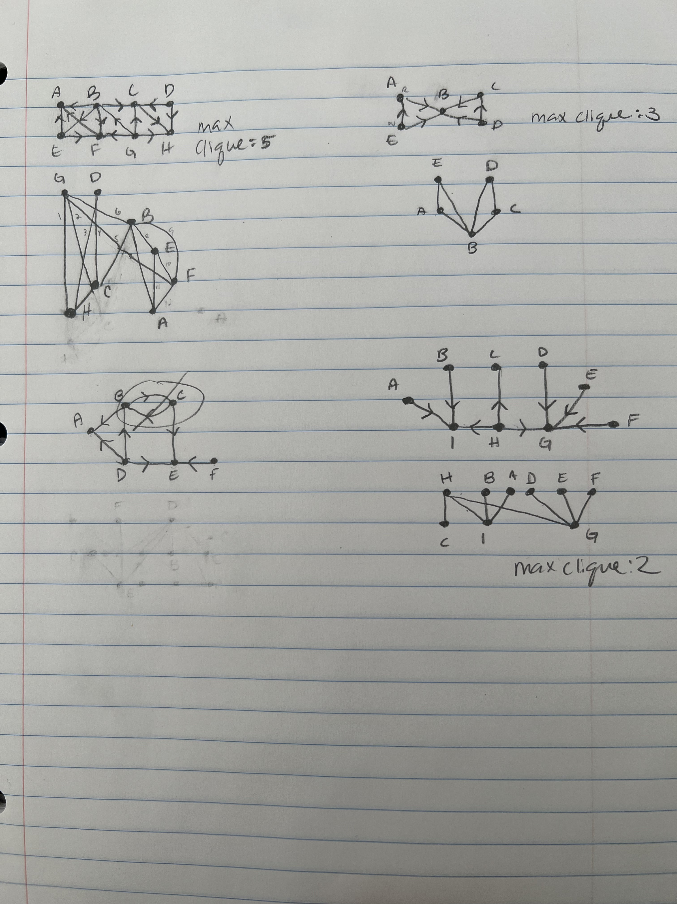  
   
   
Due on Monday 11/21/2022